Project Management System
Raji

Software Requirements Specification
Version 1.0

Danang, Jan 2025

TABLE OF CONTENTS
TABLE OF CONTENTS 2
1. DOCUMENT HISTORY 4
2. REFERENCE DOCUMENTS 4
3. INTRODUCTION 4
3.1 Purpose 5
3.2 In Scope 5
4. REQUIREMENT 5
5. OVERVIEW 6
5.1 Actors 5
5.2 System Use Case Diagram 6
5.3 System Pages Flow 6
6. SCREEN DESIGN 13

7. Data Structure 18
7.1 Entity Diagram 18
7.2 Database 18
8. NON-FUNCTIONAL REQUIREMENTS AND OTHERS 25
Performance 25
Security 25
Design Constraints 25
Standards Compliance 26
Reliability 26
Availability 26
Maintainability 26
Portability 26
9. APPENDIX

DOCUMENT HISTORY
Date | Summary of Changes | Version
17/01/2025 | Init SRS first version | PMS_SRS_sample_v1.0

REFERENCE DOCUMENTS
Document Name | Description

INTRODUCTION
The following subsections of the Software Requirements Specifications (SRS) document provide an overview of the entire SRS.

Purpose
- The Software Requirements Specification (SRS) will provide a detailed description of the requirements for the Project Management System (PMS). This SRS will allow for a complete understanding of what is to be expected of the PMS to be constructed. The clear understanding of the PMS and its’ functionality will allow for the correct software to be developed for the end user and will be used for the development of the future stages of the project. This SRS will provide the foundation for the project. From this SRS, the HMS can be designed, constructed, and finally tested.
- This SRS will be used by the software engineers constructing the PMS and Project manager. The software engineers will use the SRS to fully understand the expectations of this PMS to construct the appropriate software. Project Manager will be able to use this SRS as a “test” to see if the software engineers will be constructing the system to their expectations. If it is not to their expectations the end users can specify how it is not to their liking and the software engineers will change the SRS to fit the end users’ needs.

In Scope
- The software product to be developed is a Project Management System (PMS) designed to streamline and automate essential project management operations. The first subsystem is a Task and Workflow Management System, enabling users to create, assign, and track tasks efficiently. The second subsystem is a Collaboration and Communication System to facilitate seamless team interactions, document sharing, and discussions. The third subsystem is a Reporting and Analytics System, which provides real-time insights, progress reports, and performance tracking to aid decision-making. These three subsystems’ functionalities will be detailed in section 2—Overall Description.
The system will serve two main types of end users: team members and project managers. Both user types will have access to the Task and Workflow Management System and the Collaboration and Communication System. The Reporting and Analytics System will be restricted to project managers.
- The Project Management System’s primary objective is to provide an efficient and scalable tool for managing projects within organizations of varying sizes. The automation of project tracking, task assignment, and reporting will significantly reduce manual effort, ensuring streamlined operations even as project complexity increases.
The end users’ day-to-day project management tasks will be simplified through features like intuitive dashboards, automated notifications, and real-time collaboration. The system will prioritize user appropriateness, ease of use, quick error recovery, and overall high user satisfaction, making it an indispensable tool for effective project delivery.

REQUIREMENT
4.1 Purpose
  - Project management
  - Member management
  - Team management
  - Task management
  - Timeline management
  - Increase productivity
  - Dicussing management
  - Data Management
4.2 Requirement specification
4.2.1 Funtional Requirement
4.2.1.1 Task and workflow management
Task creation and customization: User can create tasks with titles, description and priority. Tasks can be customized and update after be created.
Workflow Automation: Customized task with define statuses : to do, in progress, done, … Automatics change status when assigned or out of date.
Task Assignment: Acording to type of project, PM can assign tasks to members or member can assign to themsevlce.
Time tracking: User can track time spent on task by using built-in calendar
4.2.1.2 Collaboration and Communication
Team communication: Built-in comment functionally for task or project discussion. Comment threads for tasks with @mention for specific members.
Notification: Real-time notifications via in app like alert, or push notification when be assigned tasks or @mention in discussions. Alert when task nearing deadlines
4.2.1.3 Reporting and analytics
Visual report: Using chart for tracking project progress
    - Burn-down chart for progress tracking
    - Gant chart for project timeline
    - Circle chart for show percentage of all status’s tasks
Custom report: Filter for generating reports by members, task type, priority,… And export report like pdf, csv or excel
4.2.1.4 User Management
Role-based permission: Admins or PM can defined roles and assign permission( create tasks, edit tasks,…)
Group: PM or admin can defiine a group and group member. Manage permission to access a group.
Guests and skateholders access: Limited, view-only access for stakeholders or external collaborators
4.2.1.5 Integration and APIs
Third-Party Integrations : Sync with calendar tools like Google Calendar and Microsoft Outlook,…
Open APIs: use RESTfull APIS for custom intergrations.

4.2.2 Non-Funtional Requirement
4.2.2.1 Usability
- Intuitive UI/UX with minimal clicks to access key features.
- Onboarding wizard for first-time users.
- Comprehensive help documentation and in-app tooltips.
4.2.2.2 Performance
- Handle up to 100 active users per project with no significant latency.
- Support for up to 50 concurrent project teams on a single server instance.
- Response time for user actions (e.g., task updates) < 1 second.
4.2.2.3 Scalability
- Horizontal scaling to support enterprise-level deployments.
- Multi-tenant architecture for large organizations.
4.2.2.4 Security
Authentication:
- Two-factor authentication and OAuth support.
- Using JWT for authentication
4.2.2.5 Reliability
Error Handling:
- Graceful error recovery with detailed logs.
- User-friendly error messages with troubleshooting steps.

4.2.3 User Requirements
4.2.3.1 Team Members
- Access to tasks, comments, and assigned projects.
- View personal productivity metrics (e.g., tasks completed weekly).
- Request project changes or additional resources.
4.2.3.2 Project Managers
- Full control over project creation and management.
- Access to team-level performance reports.
- Ability to adjust workflows, deadlines, and priorities dynamically.
4.2.4 System Requirements
4.2.4.1 Hardware
Sever Requirements:
- Processor: Quad-core, 3 GHz or higher.
- RAM: 16 GB (32 GB for enterprise setups).
- Storage: SSD, 1 TB minimum.
Client Requirements:
- Modern web browser (latest versions of Chrome, Firefox, Edge).
4.2.4.2 Software
Backend:
Node.js with Express.
Frontend:
NextJS, ShadnUI, Tailwind .
Database:
MongoDB and firebase for scalable data management.
Hosting:
Deployment on AWS.

OVERVIEW

Actors
+ Project Manager(PM)
+ Members

System Use Case Diagram

Project Manager Usecase

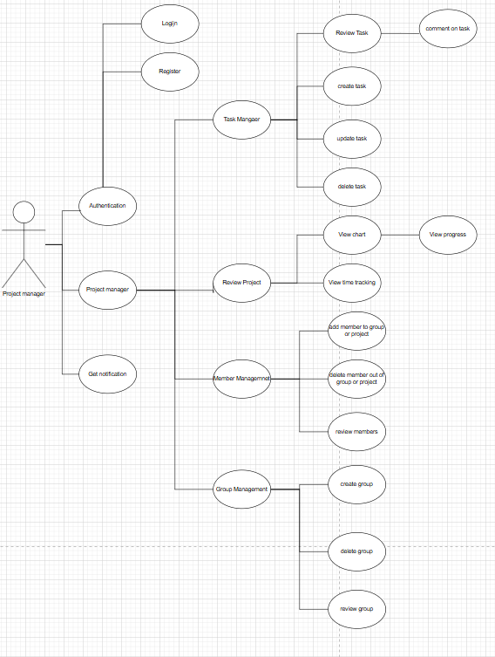

Member usecase
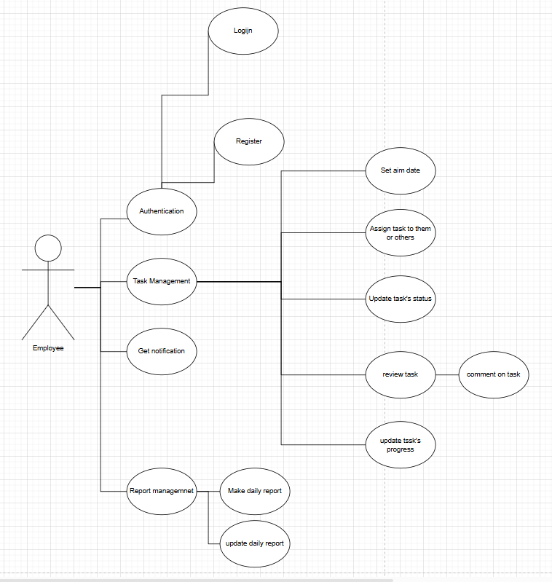

System Pages Flow
5.3.1 Management flow
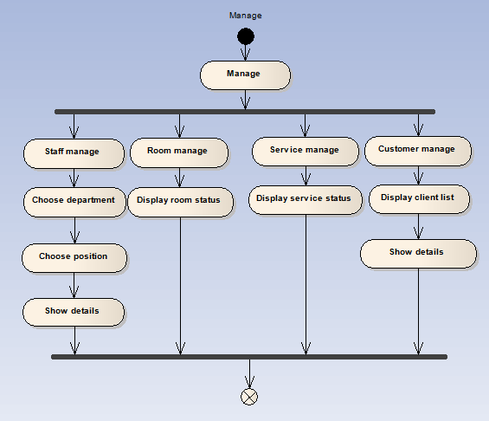
5.3.2 Booking room flow
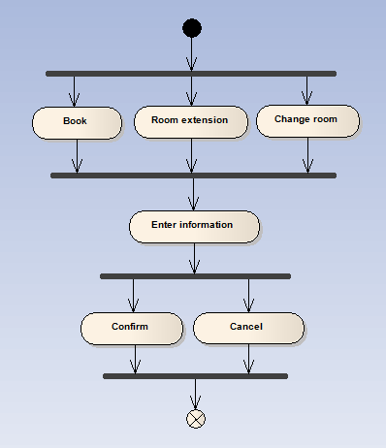
5.3.3 Service providing flow
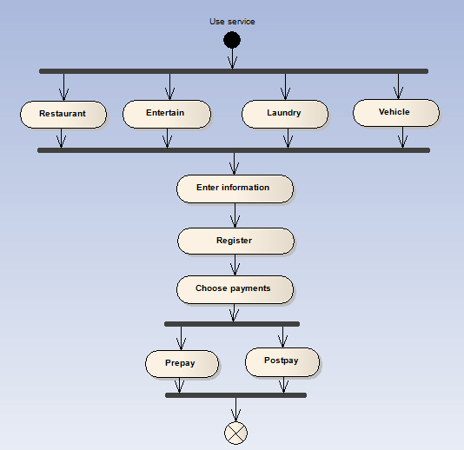

SCREEN DESIGN
+ Login
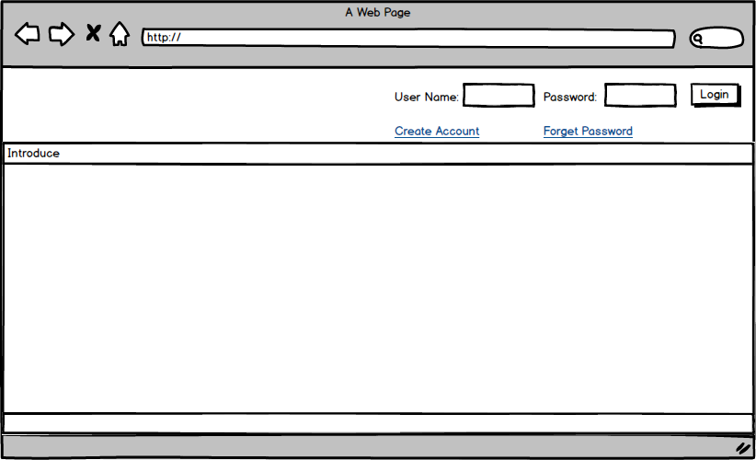

Screen | Login screen
Description | Input your user name and password to login your account. If you do not have any account, you can click to Creat account link to creat new account or click to Forget password to be help.
Screen Access | Defaut
Screen Content
Item |  | Type | Data | Description
User Name |  | Textbox | Export From Database | Here, input your user name
Password |  | Textbox | Export From Database | Input your password for your user name that you were submit.
Login |  | Button |  | To login account, Affter fishnish typing username and password, click this button. If user name or password was wrong, you can’t access to the account. You must retype and try again.
Creat Account |  | Link |  | To creat new account, you click here. New creat account layout will show.
Forget Password |  | Link |  | When you forget your password, click here for help

+ Creat new account layout
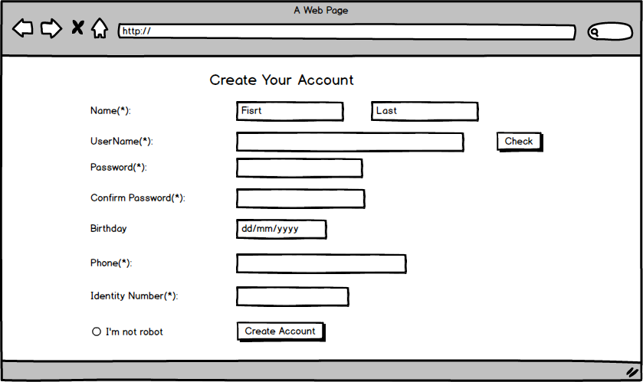

Screen | Creat account
Description |  | If you want to creat a new account, this screen will show you how. From login screen, click creat account link to view this layout. After completed insert yourself information, click Creat Account button to register a new account with OS.
Screen Access |  | User click on creat account link from login layout.
Screen Content
Item |  | Type | Data | Description
Name |  | textbox | Insert your name (Fisrt name & last name) | Type text
Username |  | textbox | Insert your elective user name. | Type text.
Check |  | textbox | Check database | Click button to check, if username was be register. You must be type another untill os accept
Password |  | textbox | Insert your register password. | Type text
Confirm Password |  | textbox |  | Retype password from password item
Birthday |  | Textbox (dd/mm/yyyy) | Insert your birthday | Type your birthday.
Phone |  | Textbox (number) | Insert your phone number | Insert your cell phone
Identity Number |  | Textbox (number) | Insert your identity number | Insert your identity number to confirm yourself.
I’m not robot |  | Radio button |  | Click or not
Creat Account |  | button |  | Click it to fishnish creat account process. If there an emty item, you have to comple to fishnish.

+ Booking room
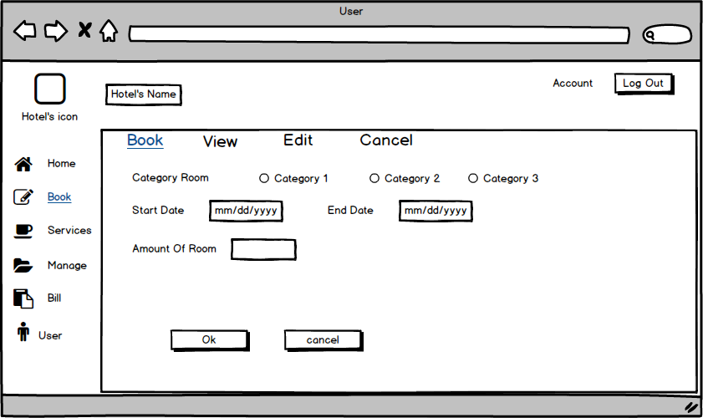
Screen | Book
Description |  | Describe how and what to do when you are booking room by your account on Hotel’s website
Screen Access |  | Click Book from Book menu. ( Or default)
Screen Content
Item |  | Type | Data | Description
Hotel’s icon |  | Image box |  | Insert image of the hotel.
Hotel’s name |  | Label |  | Insert name of the hotel.
Log out |  | Button |  | Click Log out button to log out account, and comple a session.
Category room |  | Radio check |  | Show 3 kind of room for you to choose one.
Start day |  | Textbox |  | Insert date you start stating the hotel
End day |  | Textbox |  | Insert date you going to leave.
Amount of room |  | Number |  | Insert here how much do you want to reservation.
Ok |  | button |  | Click Ok, You will submit a new resevation. Its ok if you entire the propose box. If not, you have to complete the text.
Cancel |  | button |  | Cancel the booking room session when you click Cancel button here.

+ Booking (view)
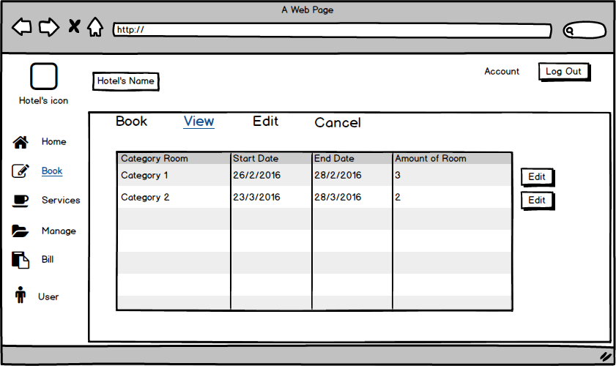
Screen | View
Description |  | It’s view show booking information. Here you can see what you were registered room, and you can change if you want. You click edit button to show edit screen.
Screen Access |  | Click view item from Book menu.
Screen Content
Item |  | Type | Data | Description
Table |  | List data | Export from database | Descrisbing information about register room of user.
Edit |  | Button |  | Button to change your register.
+ Booking (edit)
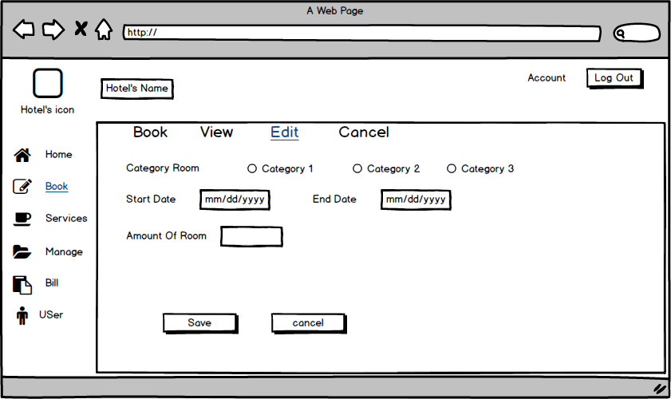
Screen | Edit
Description |  | Update or register again. Click save or cancel to finish
Screen Access |  | Click edit item from Book menu
Screen Content
Item |  | Type | Data | Description
Category room |  | Radio checkbox |  | Show 3 kind of room for choose. You can choose one of them
Start day |  | Textbox |  | Insert start day follow format
End day |  | Textbox |  | Insert end day follow format
Amount of room |  | Number |  | Insert amount of room you want to register
Save |  | Button |  | Click it to Save and update information in this Form. The old data will be delete befor update new data.
Cancel |  | button |  | Click this to cancel update, the data don’n be delete.

+ Booking (Cancel)
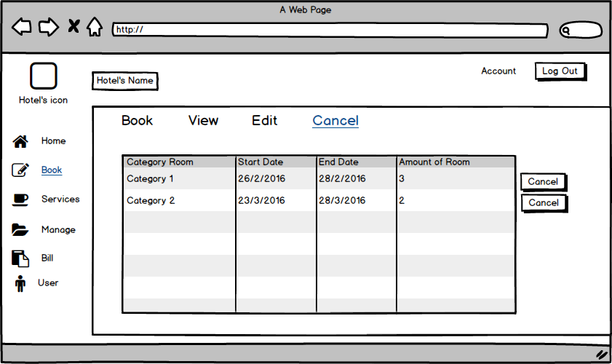
Screen | Cancel
Description |  | Update or register again. Click save or cancel to finish
Screen Access |  | Click edit item from Book menu
Screen Content
Item |  | Type | Data | Description
Table |  | table | Export from database | Descrisbing information about register room of user.
Cancel |  | Button |  | Click here if you want to Cancel your register befor. When Cancel button was be click, its will show you a dialog box to confirm your decide.

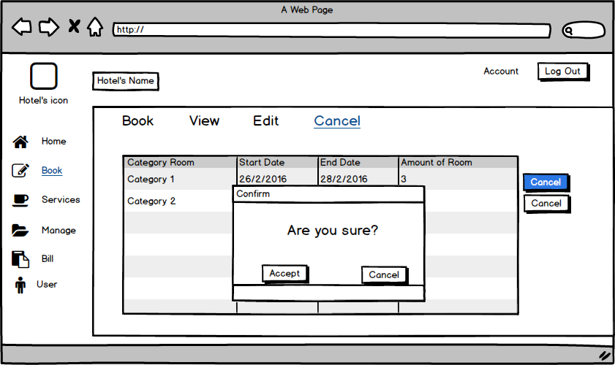
Screen | Cancel
Description |  | Update or register again. Click save or cancel to finish
Screen Access |  | Click edit item from Book menu
Screen Content
Item |  | Type | Data | Description
Accept |  | button | List menu | If you click this button then the data in table will be delete, also in the database. Return Cancel screen but you will not see the table anymore .
Cancel |  | button | Day, month, year (d/m/y) | Click Cancel button. Return Cancel screen, and nothing is change.

+ Service (Restaurant)
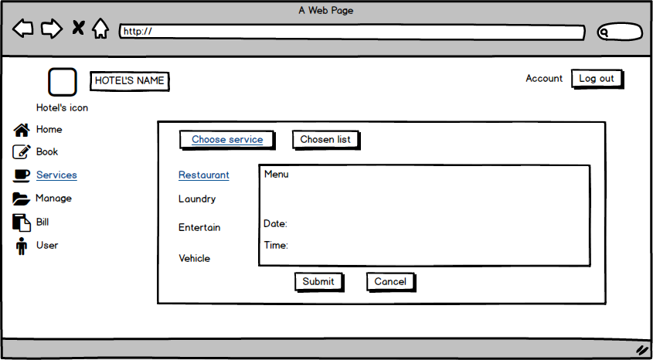

Screen | Service Restaurant
Description |  | Displays a list of the dishes, drinks and date, time.
Screen Access |  | Users click Submit, Cancel or Chosen list on Screen.
Screen Content
Item |  | Type | Data | Description
Menu |  | Text | List menu | Display information of list menu.
Date |  | Date | Day, month, year (d/m/y) | Display information of day.
Time |  | Time | Time (h:m) | Display information of year.
Submit |  | Button |  | Submit
Cancel |  | Button |  | Cancel
Screen Actions
Action Name |  | Description |  | Success | Failure
Submit |  | Click Submit to select menu list.
Cancel |  | Click Cancel to cancel
Chosen list |  | View chosen list |  | Display a selected list
+ Service (Chosen list)
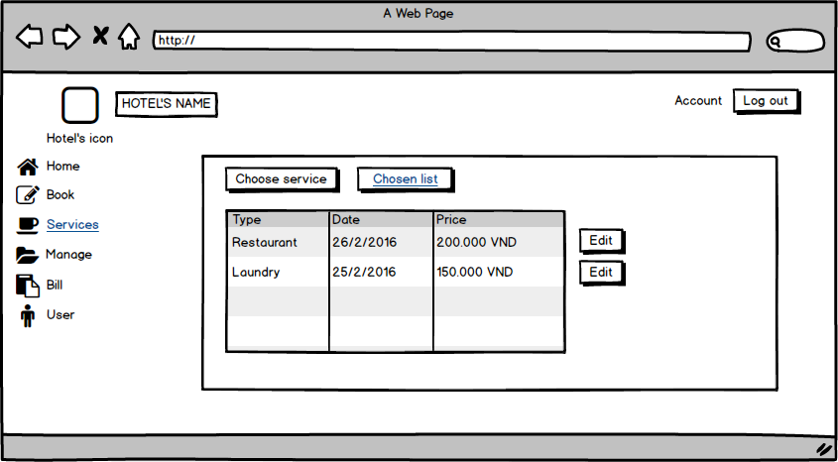
Screen | Service Chosen list
Description |  | Displays Chosen list.
Screen Access |  | Users click edit button on Screen.
Screen Content
Item |  | Type | Data | Description
Type |  | Text | Service list | Display information of service.
Date |  | Date | Day, month, year (d/m/y) | Display information of day.
Price |  | Float | Money | Display Price.
Edit |  | Button
Chosen list |  | Button |  | Chosen list
Choose service |  | Button |  | Choose service
Screen Actions
Action Name |  | Description |  | Success | Failure
Edit |  | Click Edit to edit information of services.

+ Service (Laundry)
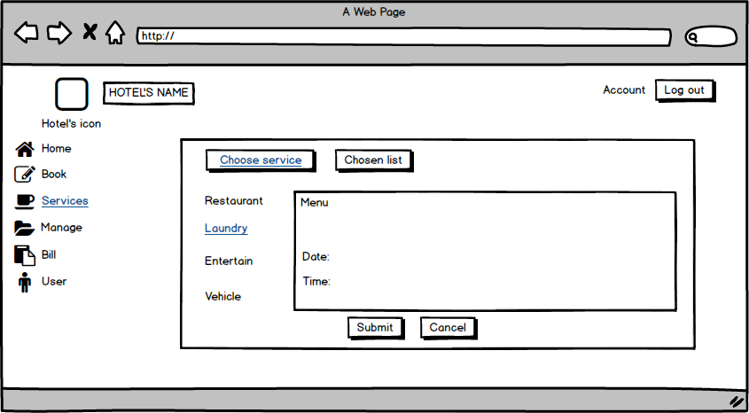
Screen | Service Laundry
Description |  | Displays a list of the service laundry.
Screen Access |  | Users click Submit, Cancel or Chosen list on Screen.
Screen Content
Item |  | Type | Data | Description
Menu |  | Text | List menu | Display information of list menu.
Date |  | Date | Day, month, year (d/m/y) | Display information of day.
Time |  | Time | Time (h:m) | Display information of year.
Submit |  | Button |  | Submit
Cancel |  | Button |  | Cancel
Screen Actions
Action Name |  | Description |  | Success | Failure
Submit |  | Click Submit to select menu list.
Cancel |  | Click Cancel to cancel
Chosen list |  | View chosen list |  | Display a list of selected

+ Service (Entertainment)
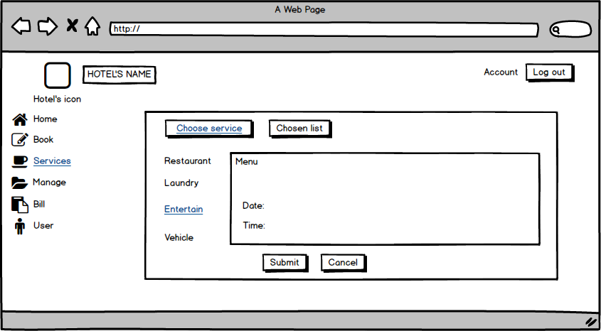
Screen | Service Entertainment
Description |  | Displays a list of the Service Entertainment.
Screen Access |  | Users click Submit, Cancel or Chosen list on Screen.
Screen Content
Item |  | Type | Data | Description
Menu |  | Text | List menu | Display information of list menu.
Date |  | Date | Day, month, year (d/m/y) | Display information of day.
Time |  | Time | Time (h:m) | Display information of year.
Submit |  | Button |  | Submit
Cancel |  | Button |  | Cancel
Screen Actions
Action Name |  | Description |  | Success | Failure
Submit |  | Click Submit to select menu list.
Cancel |  | Click Cancel to cancel
Chosen list |  | View chosen list |  | Display a list of selected

+ Service (Vehicle)
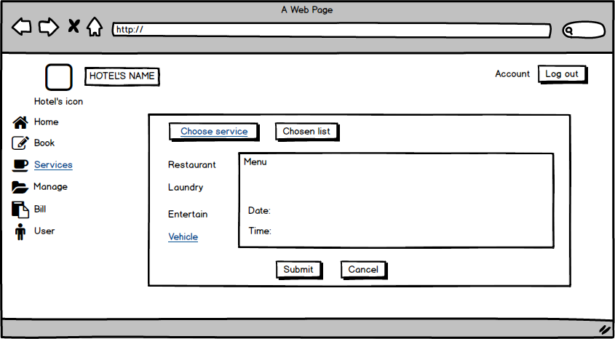
Screen | Service Vehicle
Description |  | Displays a list of the Service Vehicle.
Screen Access |  | Users click Submit, Cancel or Chosen list on Screen.
Screen Content
Item |  | Type | Data | Description
Menu |  | Text | List menu | Display information of list menu.
Date |  | Date | Day, month, year (d/m/y) | Display information of day.
Time |  | Time | Time (h:m) | Display information of year.
Submit |  | Button |  | Submit
Cancel |  | button |  | Cancel
Screen Actions
Action Name |  | Description |  | Success | Failure
Submit |  | Click Submit to select menu list.
Cancel |  | Click Cancel to cancel
Chosen list |  | View chosen list |  | Display a list of selected

+ Manage Staff
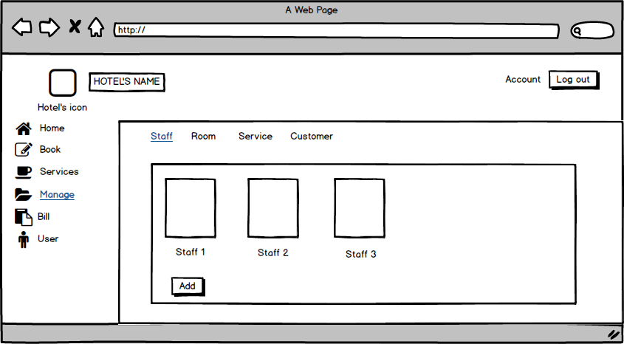
Screen | Manage Staff
Description |  | Displays a list Staff and add Staff.
Screen Access |  | Users click on add to add Staff
Screen Content
Item |  | Type | Data | Description
Staff 1 |  | Text | information of Staff 1 | - Display information of Staff 1
Staff 2 |  | Text | information of Staff 2 | - Display information of Staff 2
Staff 3 |  | Text | information of Staff 3 | - Display information of Staff 3
Add |  | Button |  | - User click on button to add Staff
Screen Actions
Action Name |  | Description |  | Success | Failure
Add |  | User click on button to add Staff |  | Display list of Staff.

+ Manage Staff (Add Staff)
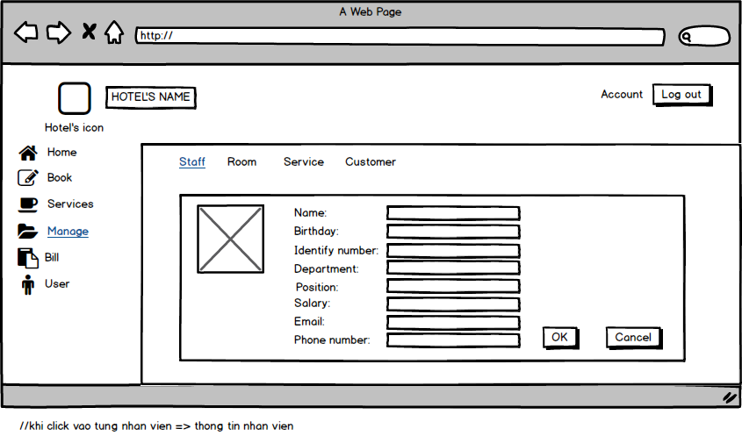
Screen | Add Staff
Description |  | Add Staff: Name, birthday, Email ……
Screen Access |  | Add information of Staff
Screen Content
Item |  | Type | Data | Description
Name |  | Textbox | Name off staff | - User enter name
Birthday |  | Date | Dd/mm/yy | - User enter your birthday
Identify number |  | Number(15) | Number | - User enter Identify number
Department |  | Text | Department of staff | - User enter department
Position |  | Text | Position | - User enter your position
Salary |  | Number | Salary | - User enter your Salary
Email |  | text | email | - User enter your Email
Phone Number |  | Number | Phone number | - User enter your phone number
Ok |  | button |  | - User click to add
Cancel |  | button |  | - User click to cancel
Screen Actions
Action Name |  | Description |  | Success | Failure
Ok |  | User click Ok to agree add information off staff. |  | Display messgage “Ok”. | Display messgage “Failed”.
Cancel |  | User click cancel to not agree add information off staff.

+ Manage Staff (Edit Staff)
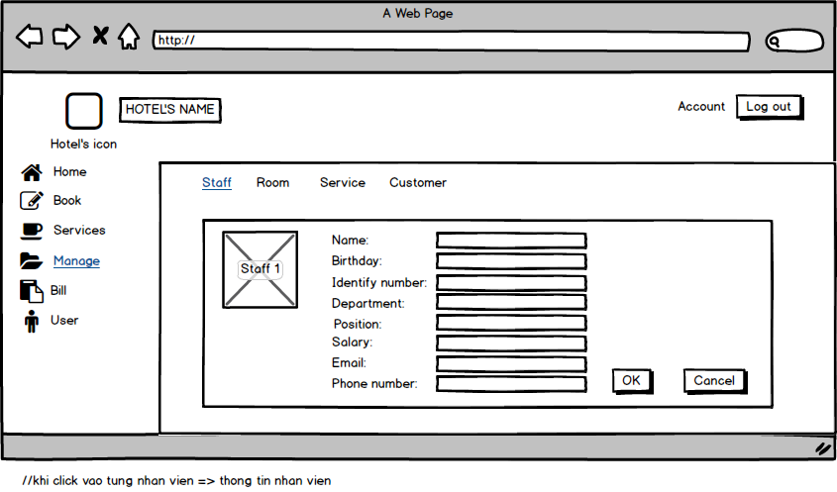
Screen | Edit Staff
Description |  | Edit Staff: Name, birthday, Email ……
Screen Access |  | Edit information of Staff
Screen Content
Item |  | Type | Data | Description
Name |  | Textbox | Name off staff | - User enter name
Birthday |  | Date | Dd/mm/yy | - User enter your birthday
Identify number |  | Number(15) | Number | - User enter Identify number
Department |  | Text | Department of staff | - User enter department
Position |  | Text | Position | - User enter your position
Salary |  | Number | Salary | - User enter your Salary
Email |  | text | email | - User enter your Email
Phone Number |  | Number | Phone number | - User enter your phone number
Ok |  | Button |  | - User click to edit
Cancel |  | Button |  | - User click to cancel
Screen Actions
Action Name |  | Description |  | Success | Failure
Ok |  | User click Ok to agree edit information off staff. |  | Display messgage “Ok”. | Display messgage “Failed”.
Cancel |  | User click Ok to not edit information off staff.

+ Manage Staff (View Staff)
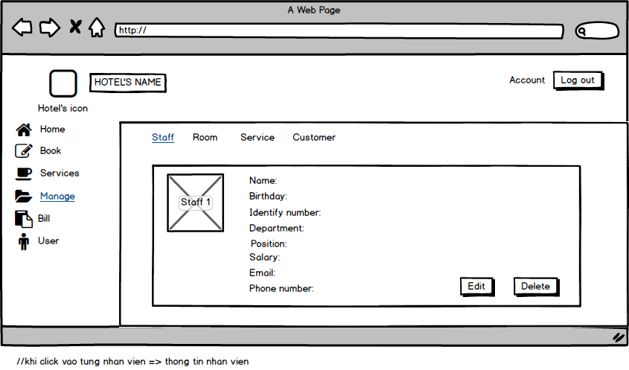
Screen | View Staff
Description |  | View Staff: Name, birthday, Email ……
Screen Access |  | View information of Staff
Screen Content
Item |  | Type | Data | Description
Name |  | Textfield | Name off staff | - Displays name
Birthday |  | Date | Dd/mm/yy | - Displays birthday
Identify number |  | Number(15) | Number | - Displays Identify number
Department |  | Text | Department of staff | - Displays department
Position |  | Text | Position | - Displays position
Salary |  | Number | Salary | - Displays Salary
Email |  | Text | email | - Displays Email
Phone Number |  | Number | Phone number | - Displays phone number
Edit |  | Button |  | - User click to edit
Delete |  | Button |  | - User click to delete
Screen Actions
Action Name |  | Description |  | Success | Failure
Edit |  | User click Edit to edit.
Delete |  | User click delete to delete

+ Manage Staff (Delete Staff)
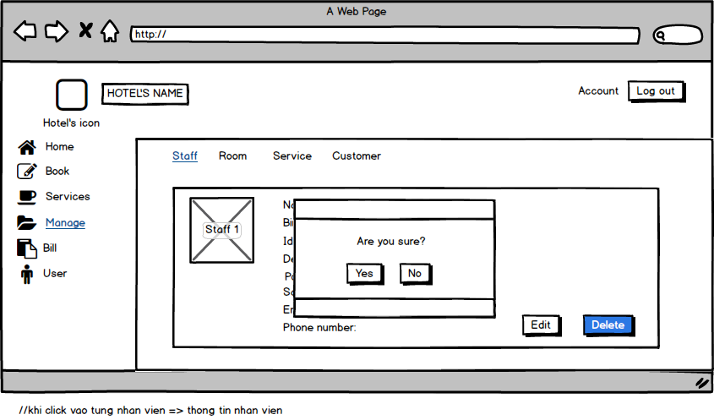
Screen | Delete Staff
Description |  | Delete Staff: Name, birthday, Email ……
Screen Access |  | Delete information of Staff
Screen Content
Item |  | Type | Data | Description
Name |  | Textfield | Name off staff | - Displays name
Birthday |  | Date | Dd/mm/yy | - Displays birthday
Identify number |  | Number(15) | Number | - Displays Identify number
Department |  | Text | Department of staff | - Displays department
Position |  | Text | Position | - Displays position
Salary |  | Number | Salary | - Displays Salary
Email |  | Text | email | - Displays Email
Phone Number |  | Number | Phone number | - Displays phone number
Yes |  | Button |  | - User click to delete staff
No |  | Button |  | - User click to not delete staff
Screen Actions
Action Name |  | Description |  | Success | Failure
Yes |  | User click to delete staff |  | Display messgage “delete success”.
No |  | User click to not delete staff

+ Manage Room
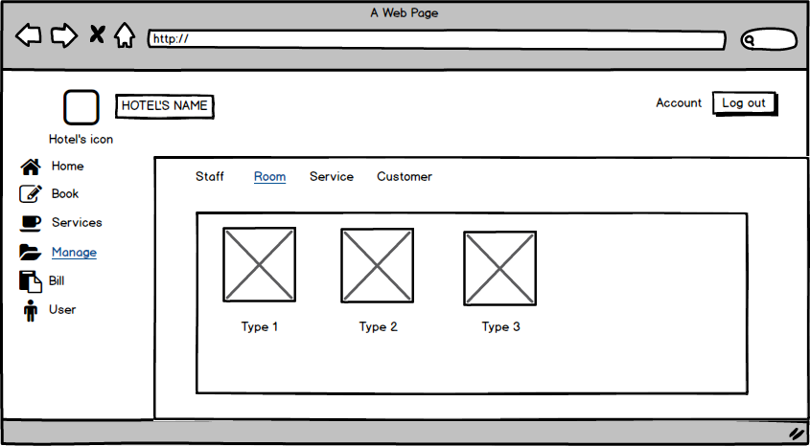
Screen | Manage Room
Description |  | Displays Room list and information
Screen Access |  | View Room list and information

+ Manage Room (Add Room)
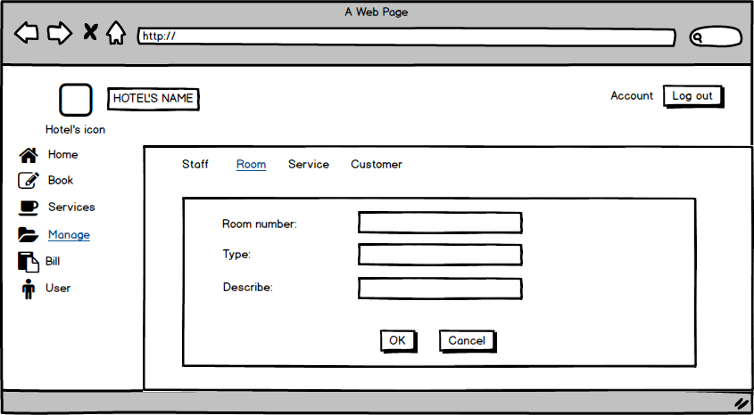
Screen | Add Room
Description |  | Add Room: Room number, type, Describe
Screen Access |  | Add information of Room
Screen Content
Item |  | Type | Data | Description
Room number |  | Number | number | - enter number of room
Type |  | Text | Text | - enter type of room
Describe |  | Text | Text | - enter Describe of room
Ok |  | Button |  | - click to add room
Cancel |  | Button |  | - click to cancel
Screen Actions
Action Name |  | Description |  | Success | Failure
Ok |  | User click Ok to agree add room |  | Display messgage “Ok”. | Display messgage “Failed”.
Cancel |  | User click cancel to cancel

+ Manage Room (View Room)
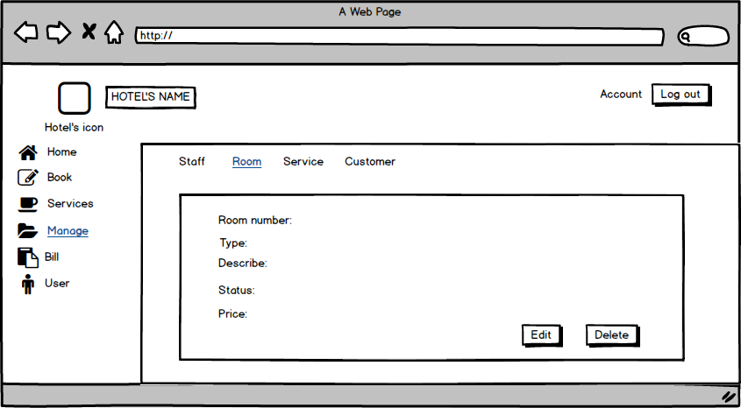
Screen | View Room
Description |  | View room: Room number, type, Describe, status, price
Screen Access |  | View information of Room
Screen Content
Item |  | Type | Data | Description
Room number |  | Number | number | - Display number of room
Type |  | Text | Text | - Display type of room
Describe |  | Text | Text | - Display Describe of room
Status |  | Text | Text | - Displays status of room
Price |  | Number | Number | - Displays price of room
Edit |  | Button |  | - Click to edit
Delete |  | Button |  | - Click to delete
Screen Actions
Action Name |  | Description |  | Success | Failure
Edit |  | User click Edit to edit.
Delete |  | User click delete to delete

+ Manage Room (Edit Room)
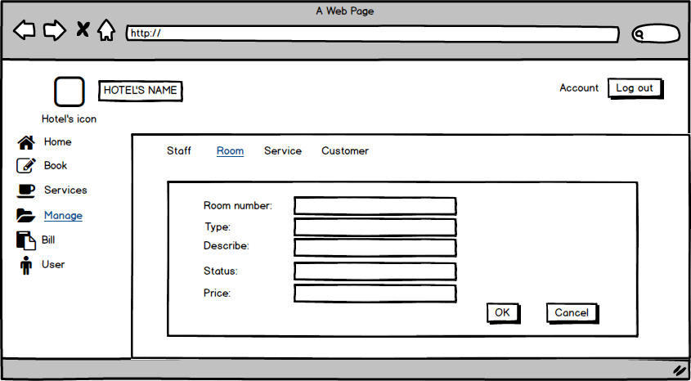
Screen | Edit Room
Description |  | Edit Room: Room number, type, Describe, status, price
Screen Access |  | Edit information of room
Screen Content
Item |  | Type | Data | Description
Room number |  | Textbox | number | - enter number of room
Type |  | Textbox | Text | - enter type of room
Describe |  | Textbox | Text | - enter Describe of room
Status |  | Textbox | Text | - enter status of room
Price |  | Textbox | Number | - enter price of room
Ok |  | Button |  | - User click to edit
Cancel |  | Button |  | - User click to cancel
Screen Actions
Action Name |  | Description |  | Success | Failure
Ok |  | User click Ok to agree edit information off room. |  | Display messgage “Ok”. | Display messgage “Failed”.
Cancel |  | User click Ok to not edit information off room.

+ Manage Room (Delete Room)
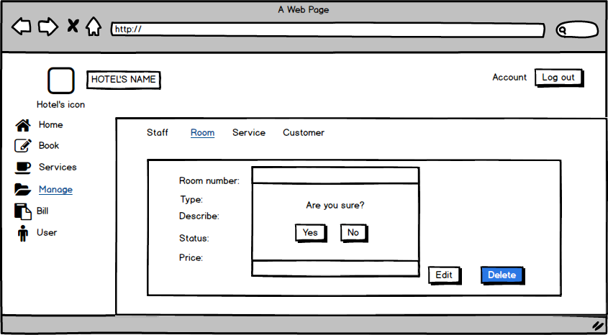
Screen | Delete Room
Description |  | Delete room: Room number, type, Describe, status, price
Screen Access |  | Delete information of room
Screen Content
Item |  | Type | Data | Description
Room number |  | Textbox | number | - enter number of room
Type |  | Textbox | Text | - enter type of room
Describe |  | Textbox | Text | - enter Describe of room
Status |  | Textbox | Text | - enter status of room
Price |  | Textbox | Number | - enter price of room
Yes |  | Button |  | - User click to delete room
No |  | Button |  | - User click to not delete room
Screen Actions
Action Name |  | Description |  | Success | Failure
Yes |  | User click to delete room |  | Display messgage “delete success”.
No |  | User click to not delete room

+ Manage Service
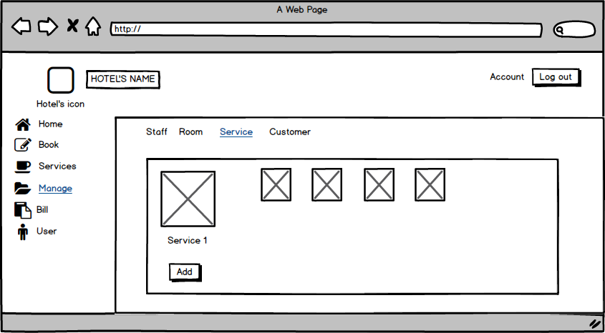
Screen | Manage Service
Description |  | Displays Service list and information for all the service of the Hotel.
Screen Access |  | Click item Service on the menu Manage.
Screen Content
Item |  | Type | Data |  | Description
Server1 |  | link |  |  | Server’s Name, link to Service information.
Table List |  | table |  |  | Show list. The information and image about the server name.
Add |  | Button |  |  | Add button, to add new Service
Screen Actions
Action Name |  | Description |  | Success |  | Failure
show service |  | Show the information of all the service.
Add |  | To add new service |  | Show add service layout for you to input new service information. |  | No action.

+ Manage Service (Add Service)
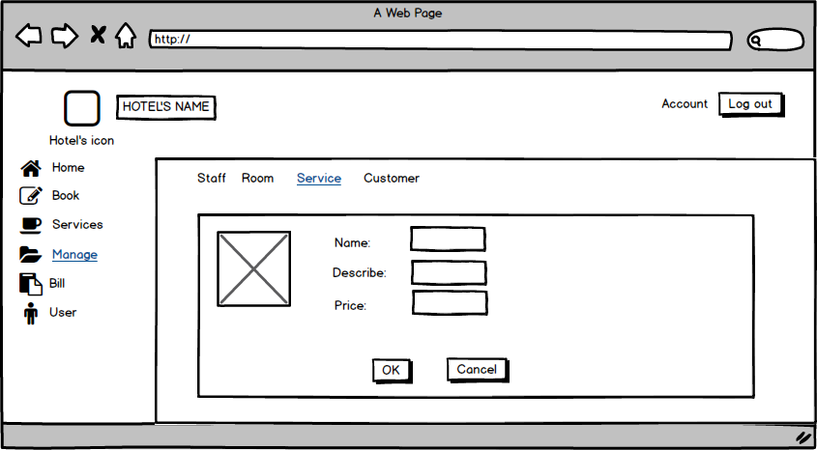
Screen | Add new Service
Description |  | Displays some textbox to input text.
Screen Access |  | Click Add button from service manage screen.
Screen Content
Item |  | Type | Data |  | Description
Image |  | Image |  |  | Image for the Service
Name |  | textbx (text) |  |  | Here get service name that your’e input.
Describe |  | textbox (text) |  |  | You can decribe some thing about the service. It’s will help the customer know what the service is?
Price |  | textbox (text) |  |  | Input here how much the service cost.
OK |  | Button |  |  | Click Ok to add the service to service manage screen.
Cancel |  | Button |  |  | Cancel button to destroy.
Screen Actions
Action Name |  | Description |  | Success |  | Failure
Input information |  | Input text
Click OK button |  | Click on the OK button |  | Add the service into service manage. |  | No action or the service you were add not display in the service manage.
Click Cancel |  | Click on the Cancel button |  | Return to service manage screen and no thing update. |  | No action, or new service will be add to service manage.

+ Manage Service (View Service)
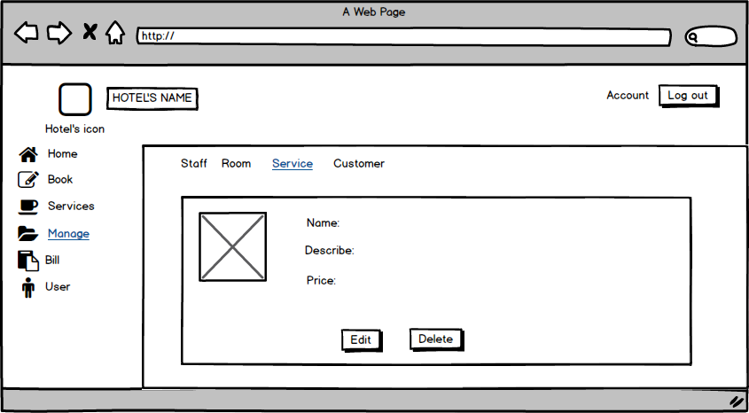
Screen | View Service
Description |  | Displays the service
Screen Access |  | Click service name (link).
Screen Content
Item |  | Type | Data |  | Description
Image |  | Image |  |  | Image for the Service
Name |  | Label (text) |  |  | Show the service name.
Describe |  | Label (text) |  |  | Show what you were describe for the service.
Price |  | Label (text) |  |  | Show the price that you were input.
Edit |  | Button |  |  | Go to Edit screen to change the information for the service.
Delete |  | Button |  |  | Delete the service form service manage.
Screen Actions
Action Name |  | Description |  | Success |  | Failure
Click Edit button |  | Click on the Edit button to do change service name, service cost or service description. |  | Show the Edit screen for you to change the information. |  | No action.
Click delete |  | Click on the delete button. |  | Show a message box to check your decide. |  | No action.

+ Manage Service (Edit Service)
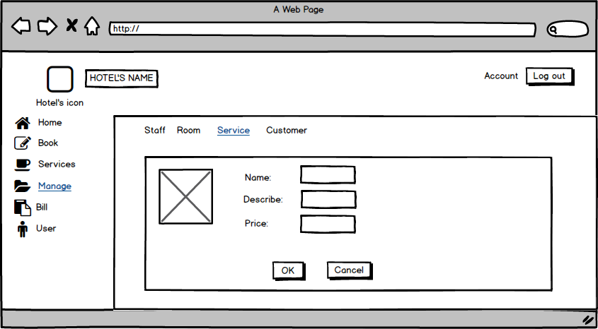
Screen | Edit Screen
Description |  | Show old the information of the service, but you can change the text.
Screen Access |  | Click Edit button from View service screen.
Screen Content
Item |  | Type | Data |  | Description
Image |  | Image |  |  | Image for the Service
Name |  | Textbox (text) |  |  | Show the service name, (can change)
Describe |  | Textbox (text) |  |  | Show what you were describe for the service. (can change)
Price |  | Textbox (text) |  |  | Show the price that you were input. (can change)
OK |  | Button |  |  | Click Ok to change and update new information about the service.
Cancel |  | Button |  |  | To dispose the changing.
Screen Actions
Action Name |  | Description |  | Success |  | Failure
Change text |  | Retype new text into the textbox.
Click OK button |  | Click on the OK button to do change service name, service cost or service description. |  | Update and show the change in service manage screen. |  | No action.
Click Cancel |  | Click on the Cancel button. |  | Show a message box to check your decide. |  | No action.

+ Manage Service (Delete Service)
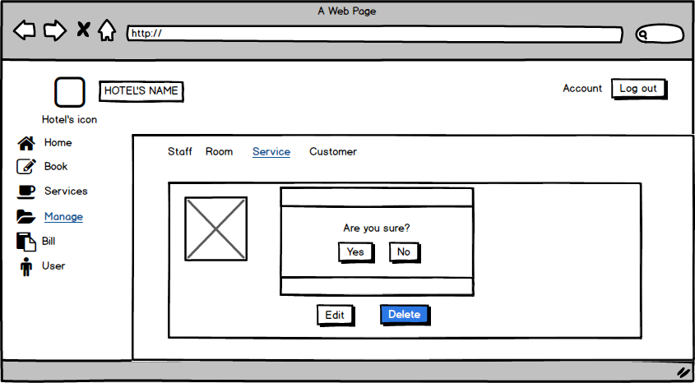
Screen | Edit Screen
Description |  | Show old the information of the service, but you can change the text.
Screen Access |  | Click Delete button from View service screen.
Screen Content
Item |  | Type | Data |  | Description
Image |  | Image |  |  | Image for the Service
Messabox |  |  | OS |  | Show a messbox with a text “Are you sure”
Yes |  | Button |  |  | To confirm you accept to delete the service.
No |  | button |  |  | To confirm you don’t allow to delete the service.
Screen Actions
Action Name |  | Description |  | Success |  | Failure
Show messbox |  | A message box will show with the text. |  | Show the text |  | No action.
Click Yes button |  | Click on the Yes button to confirm the service will be delete. |  | update and no see the service into service manage screen. The messabox disappear. |  | The service still in the service manage screen.
Click No |  | Click on the No button. |  | Show a message box to check your decide. The messabox disappear. |  | No action.

+ Manage Customer
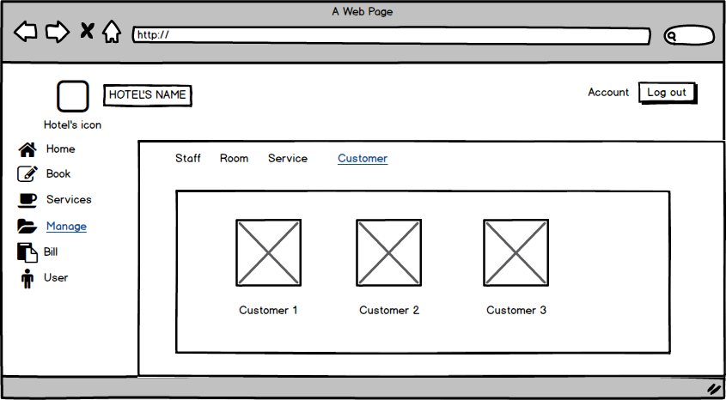
Screen | Manage Customer
Description |  | Show the customer information ( image and name)
Screen Access |  | Click iteam Customer on the menu Manage.
Screen Content
Item |  | Type | Data | Description
Image |  | Image |  | Image for the Service
Customer1 |  | link | Customer’s name | Link to Customer’s information.

+ Manage Customer (Add Service)

+ Manage Customer (View Customer)
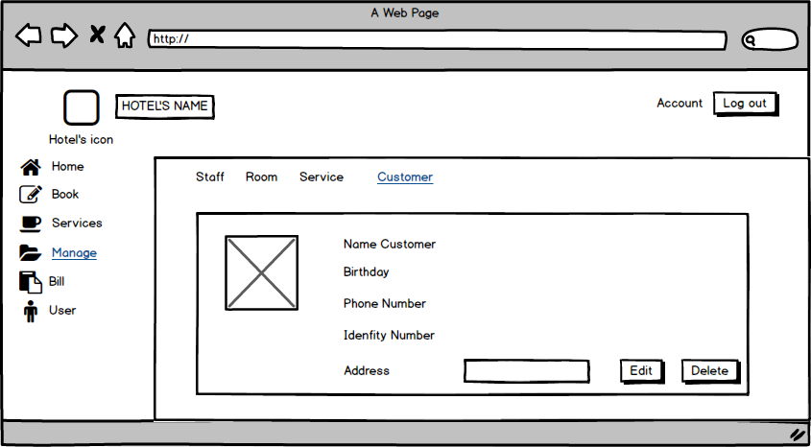
Screen | View Customer
Description |  | Show the customer information .
Screen Access |  | Click Customer name (link) From customer manage.
Screen Content
Item |  | Type | Data |  | Description
Image |  | Image |  |  | Image for the Service
Name Customer |  | Label (text) |  |  | Show Name Customer
Birthday |  | Label (text) |  |  | Show customer birthday.
Phone number |  | Label (text) |  |  | Show phone number
Identity number |  | Label (text) |  |  | Show identity number
address |  | Label |  |  | Show customer address.
Edit |  | Button |  |  | To edit Customer information
Delete |  | Buton |  |  | To delete Customer
Screen Actions
Action Name |  | Description |  | Success |  | Failure
Click Edit button |  | Click on Edit button to edit customer information. |  | Show Edit customer Screen |  | No action.
Click Delete button |  | Click on the delete button to delete customer. |  | The customer will be delete from Customer manage screen. |  | No action, Or the information of the customer not be delete.

+ Manage Customer (Edit Customer)
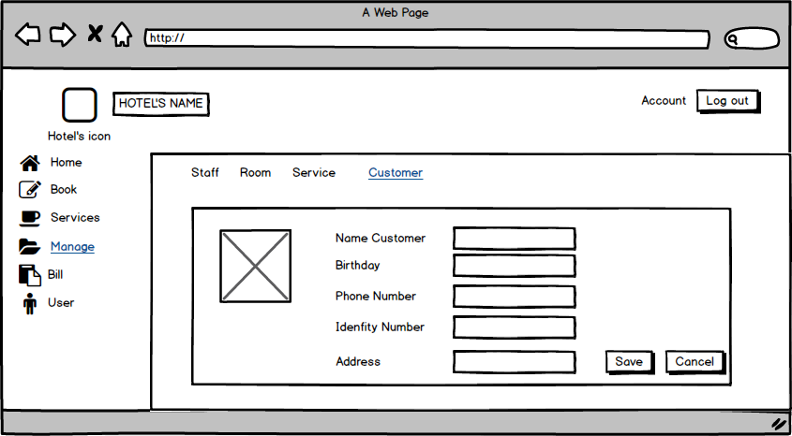
Screen | Edit Customer Screen.
Description |  | Show the customer information, and the textbox for change.
Screen Access |  | Click Edit button from Customer View Screen.
Screen Content
Item |  | Type | Data |  | Description
Image |  | Image |  |  | Show Image, Edit image
Name Customer |  | TextBox (text) |  |  | Edit Name here
Birthday |  | TextBox (text) |  |  | Edit customer birthday.
Phone number |  | TextBox (text) |  |  | Edit phone number
Identity number |  | TextBox (text) |  |  | Show identity number
address |  | TextBox (text) |  |  | Edit customer address.
Save |  | Button |  |  | To save and update Customer information
Cancel |  | Buton |  |  | Exit and return to customer view screen
Screen Actions
Action Name |  | Description |  | Success |  | Failure
Click Save button |  | Click on save button to save customer information. |  | Update customer information on customer manage. |  | No action.
Click Cancel button |  | Click on the Canel button to exit. |  | Return View Customer Screen. |  | No action.

+ Manage Customer (Delete Customer)
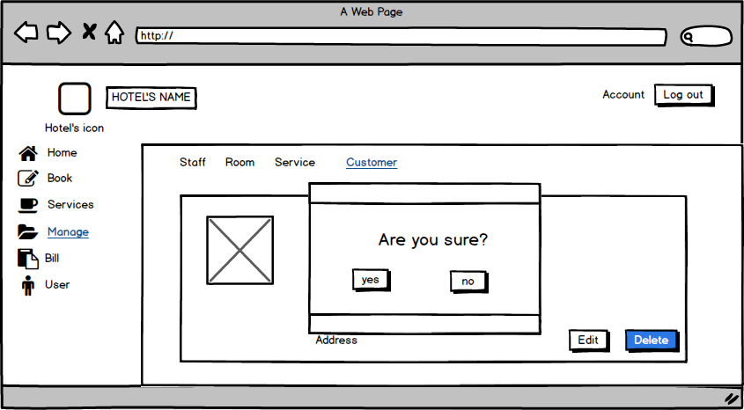
Screen | Edit Customer Screen.
Description |  | Show the customer information, and the textbox for change.
Screen Access |  | Click Delete button from Customer View Screen.
Screen Content
Item |  | Type | Data |  | Description
Image |  | Image |  |  | Show Image, Edit image
Message box |  |  |  |  | Show message box
Yes |  | Button |  |  | To confirm, you want to delete the customer information.
No |  | Buton |  |  | Exit and return to customer view screen
Screen Actions
Action Name |  | Description |  | Success |  | Failure
Click Yes button |  | Click on Yes button . |  | The customer will delete. The information abou the customer who were delete will not show in customer manage. |  | No action.
Click No button |  | Click on the No button |  | Return View Customer Screen. |  | No action.

+ Bill
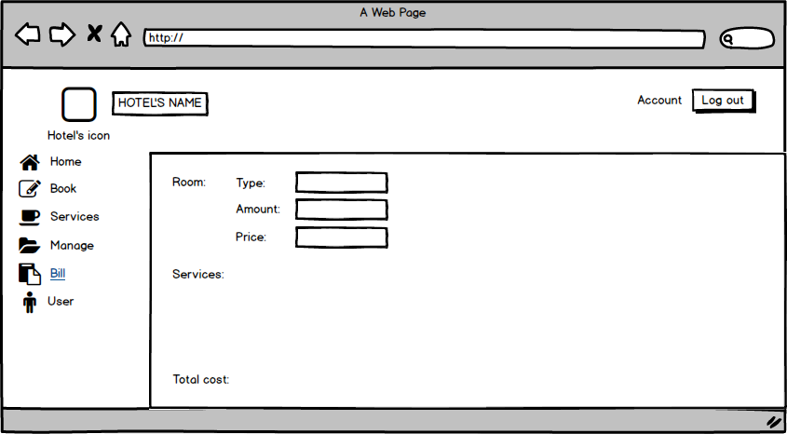
Screen | Bill
Description |  | Display information about type, amount, price of room and total cost.
Screen Access |  | View information
Screen Content
Item |  | Type | Data | Description
Type (Room) |  | Text field | Type of room | - Display information about type of room
Amount (Room) |  | Number | Number of room | - Display Number of room
Price (Room) |  | Number | Price | - Display Price
Services |  | Text field | Service list | - Display Service list
Total cost |  | Number | Total cost | - Display Total cost
+ User
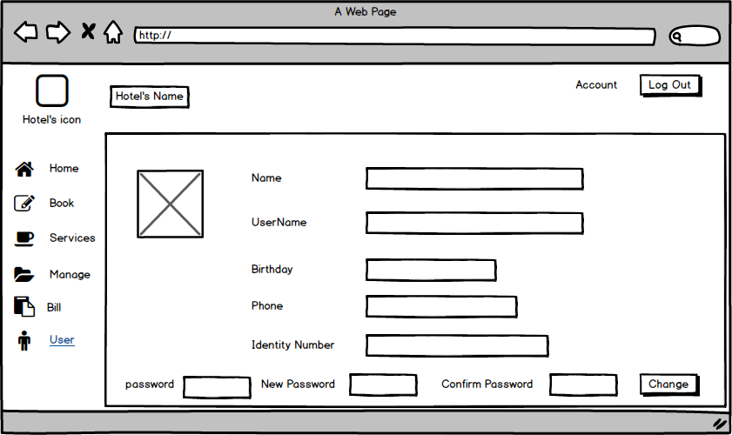
Screen | User
Description |  | This will show you : your’s name, your user name, password,Birthday, phone, Identity number. You also can change your password here if you want.
Screen Access |  | Click edit item from Book menu
Screen Content
Item |  | Type | Data | Description
name |  | Text field | Export from database | - Show your full name
User name |  | Tex field | Export from database | - Show your user name when you register with OS
Birthday |  | Tex field | Export from database | - Your birthday will show here. You should be type exactly your birthday to receice gifts from the hotel manage for your birthday.
phone |  | Tex field | Export from database | - Your cell phone number show here
Identity Number |  | Tex field | Export from database | - Your identit to confirm yourseft to us.
password |  | Text box | Insert your current password | - Text box here for you insert your current password.
New password |  | Text box | Insert text | - New password for your account
Confirm password |  | Text box | Insert text | - New password for your account.
Change |  | button |  | - Click it to change your password.

DATA STRUCTURE

Entity diagram
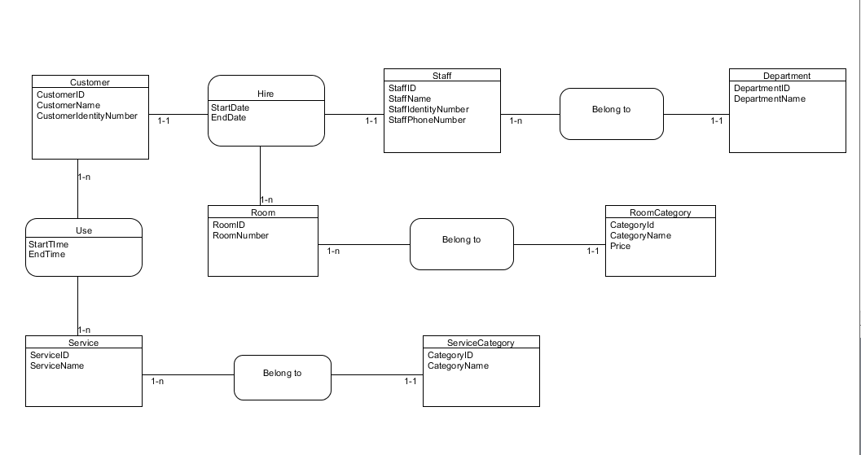

Database
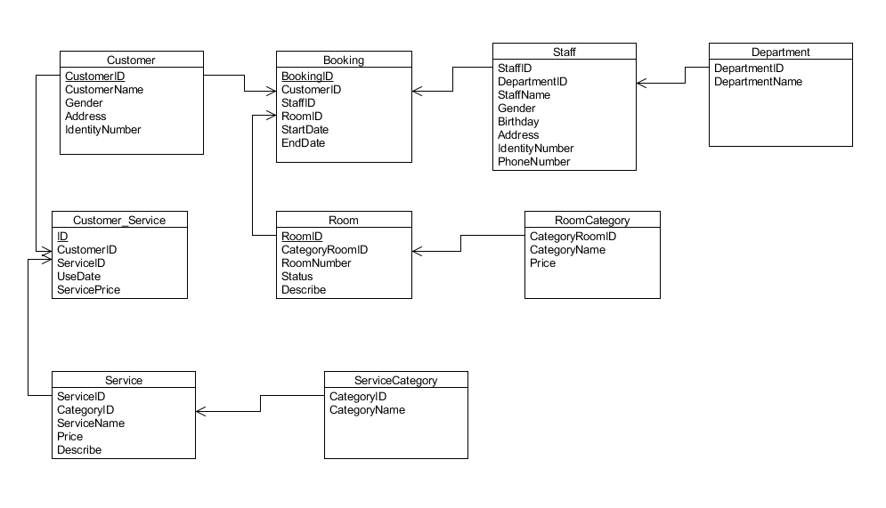

Null = Yes: allow empty value.
Null = No: disallow empty value.
PK: primary key.
FK: foreign key.
Int: 4-byte integer type.
Char: character type.
Money: monetary data types 8 bytes.
DateTime: date data type 8 bytes.
Nvarchar: Unicode data type.
ROOM
Field name | Data type | Null | Key | Note
RoomID | Int(4) | No | PK
CategoryRoomID | Int(4) | No | FK
Room number | Int(4) | No
Status | Char(1) | No |  | E: empty room  R: reserved room  B: busy room
Describe | Nvarchar(70) | Yes

ROOM CATEGORY
Field name | Data type | Null | Key | Note
CategoryRoomID | Int(4) | No | PK
CategoryName | Char(8) | No
Price | Money(8) | No |  | Price(VND)

SERVICE
Field name | Data type | Null | Key | Note
ServiceName | Int(4) | No
ServiceID | Int(4) | No | PK
Price | Float | No |  | Price(VND)
Describe | Nvarchar(70) | Yes

SERVICECATEGORY
Field name | Data type | Null | Key | Note
CategoryID | Int(4) | No | PK
CategoryName | Varchar(20) | No

STAFF
Field name | Data type | Null | Key | Note
StaffID | Int(4) | No | PK
DepartmentID | Int(4) | No | FK
StaffName | Nvarchar(20) | No
Gender | Char(1) | No |  | O: male  X: female
Birthday | DateTime(8) | Yes
Address | Nvarchar(20) | Yes
IdentityNumber | Int(9) | No
PhoneNumber | Int(11) | Yes

DEPARTMENT
Field name | Data type | Null | Key | Note
DepartmentID | Int(4) | No | PK
DepartmentName | Nvarchar(20) | No

CUSTOMER
Field name | Data type | Null | Key | Note
CustomerID | Int(4) | No | PK
CustomerName | Nvarchar(20) | No
Gender | Char(1) | No |  | O: male  X: female
Address | Nvarchar(20) | Yes
IdentityNumber | Int(9) | Yes

BOOKING
Field name | Data type | Null | Key | Note
BookingID | Int(4) | No | PK
CustomerID | Int(4) | No | FK
StaffID | Int(4) | No | FK
RoomID | Int(4) | No | FK
StartDate | DateTime(8) | No
EndDate | DateTime(8) | No

CUSTOMER_SERVICE
Field name | Data type | Null | Key | Note
ID | Int(4) | No | PK
CustomerID | Int(4) | No | FK
ServiceID | Int(4) | No | FK
ServicePrice | Float | No

NON-FUNCTIONAL REQUIREMENTS AND OTHERS

Performance
No. | Requirement
1. | The load time for user interface screens shall take no longer than two seconds.
2. | The log in information shall be verified within five seconds.
3. | Queries shall return results within five seconds.

Security
No. | Requirement
1. | Customer Service Representatives and Managers will be able to log in to the Hotel Management System.
2. | Customer Service Representatives will have access to the Reservation/Booking and Food subsystems
3. | Managers will have access to the Management subsystem as well as the Reservation/Booking and Food subsystems
4. | Access to the various subsystems will be protected by a user log in screen that requires a user name and password

Design Constraints
No. | Requirement
1. | The Hotel Management System shall be a stand-alone system running in a Windows environment.
2. | The system shall be developed using PHP and an MySQL database.

Standards Compliance
No. | Requirement
1. | There shall be consistency in variable names within the system. The graphical user interface shall have a consistent look and feel.

Reliability
No. | Requirement
1. | Specify the factors required to establish the required reliability of the software system at time of delivery

Availability
No. | Requirement
1. | The system shall be available during normal hotel operating hours.

Maintainability
No. | Requirement
1. | The Hotel Management System is being developed in PHP. PHP is an object oriented programming language and shall be easy to maintain.

Portability
No. | Requirement
1. | The Hotel Management System shall run in any Microsoft Windows environment that contains the MySQL database

Hardware
Type | Tower
CPU | 1 x Xeon E3-1225v3 (3.2Ghz-1600Mhz-8Mb)
Max CPU | 1
RAM | 4Gb 4 x UDIMM, 1600 MT/s Slots
Disk | 1Tb
NIC | Ethernet Gigabit
Slot | 4 x PCIe slots
Power | 290W
Max power supply | 1

